EMPLOYEE MANAGEMENT
SYSTEM

A Project Report
Submitted in fulfillment of the requirements for the Placement Class Assignment

Bachelor of Engineering in
Computer Science Engineering
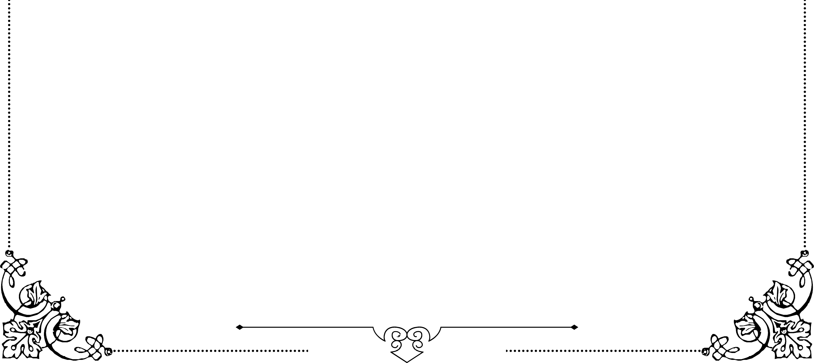
Submitted by
Jaya Niketha T

INTRODUCTION
The Employee Management System (EMS) is a robust and integrated platform designed to simplify and centralize the human resource functions of an organization. In modern workplaces, managing employee data manually can be time-consuming, prone to errors, and inefficient. EMS addresses these challenges by providing a digital solution to maintain comprehensive employee records, including personal details, job roles, attendance, and performance

The system enables HR personnel to efficiently add, update, and modify employee information, manage leave requests, track attendance, and oversee payroll operations with minimal effort. Moreover, the Employee module allows employees to access their personal information, such as leave balance, salary details, and other relevant records, promoting transparency and self-service. By consolidating these functionalities into a single platform, the EMS not only reduces administrative workload but also fosters effective communication between employees and management.

The system ensures accurate record-keeping, timely payroll processing, and streamlined HR workflows, thereby enhancing overall organizational efficiency. Ultimately, the Employee Management System contributes to a structured, transparent, and productive work environment, aligning HR processes with the goals of modern businesses.

Problem Statement
In many organizations, human resource management involves handling a large volume of employee information, including personal details, attendance, leave records, and payroll. When these processes are managed manually using paper files or separate spreadsheets, they become time-consuming, error-prone, and inefficient. Tracking leave requests, updating employee records, calculating salaries, and generating reports often lead to delays and inconsistencies.
Additionally, lack of a centralized system limits transparency and makes it difficult for employees and management to access up-to-date information. This can result in communication gaps, administrative bottlenecks, and reduced productivity.
The Employee Management System aims to address these challenges by providing a centralized, automated platform to manage all employee-related activities efficiently. It ensures accurate record-keeping, easy access to information, streamlined HR processes, and improved communication between employees and management, ultimately creating a more organized and productive work environment.

Objectives of the System
The main objectives of the Employee Management System are:
- Centralized Employee Data Management – To maintain all employee records, including personal details, job roles, attendance, leave history, and salary information, in a centralized digital platform.
- Efficient HR Operations – To streamline HR activities such as adding, updating, and modifying employee records, processing leave requests, and managing payroll efficiently.
- Transparency and Accessibility – To provide employees and management easy access to relevant information, ensuring transparency in HR processes.
- Error Reduction – To minimize errors associated with manual record-keeping and calculations by automating key HR functions.
- Improved Communication – To facilitate effective communication between employees and management regarding leave approvals, salary details, and other HR-related matters.
- Enhanced Productivity – To save time and administrative effort, allowing HR personnel to focus on strategic tasks and contribute to a more organized and productive work environment.

System Architecture Overview

The Employee Management System (EMS) is designed using a multi-tier architecture to ensure scalability, maintainability, and efficient performance. The system typically consists of three main layers:
- Presentation Layer (Frontend)
  - This is the user interface of the system, where employees and HR personnel interact with the application.
  - It provides forms and dashboards to view, add, update, or delete employee information, apply for leaves, and check salary details.
  - Technologies like HTML, CSS, JavaScript, and frontend frameworks (e.g., React, Angular, or Thymeleaf) can be used to build a responsive and user-friendly interface.
- Business Logic Layer (Backend)
  - This layer contains the core functionality and logic of the EMS.
  - It processes user requests, applies business rules, handles leave approvals, calculates salaries, and manages employee data.
  - Typically implemented using server-side languages such as Java (Spring Boot), Python (Django/Flask), or Node.js.
- Data Layer (Database)
  - The database layer stores all employee-related information securely, including personal details, attendance records, leave history, and payroll data.
  - Relational databases such as MySQL, PostgreSQL, or Oracle are commonly used for structured storage and easy retrieval.
  - This layer ensures data integrity, security, and fast access to information.
Additional Components:
- Authentication & Authorization: Ensures that only authorized users can access sensitive data.
- Reporting Module: Generates reports related to attendance, payroll, and leave statistics.
- APIs: Facilitate communication between the frontend and backend, making the system modular and scalable.
Workflow Summary:
- User interacts with the frontend.
- Requests are sent to the backend for processing.
- Backend retrieves or updates data in the database.
- Responses are sent back to the frontend for display.
This architecture ensures efficient management of employee data, reduces redundancy, enhances security, and provides a seamless experience for both employees and HR personnel.

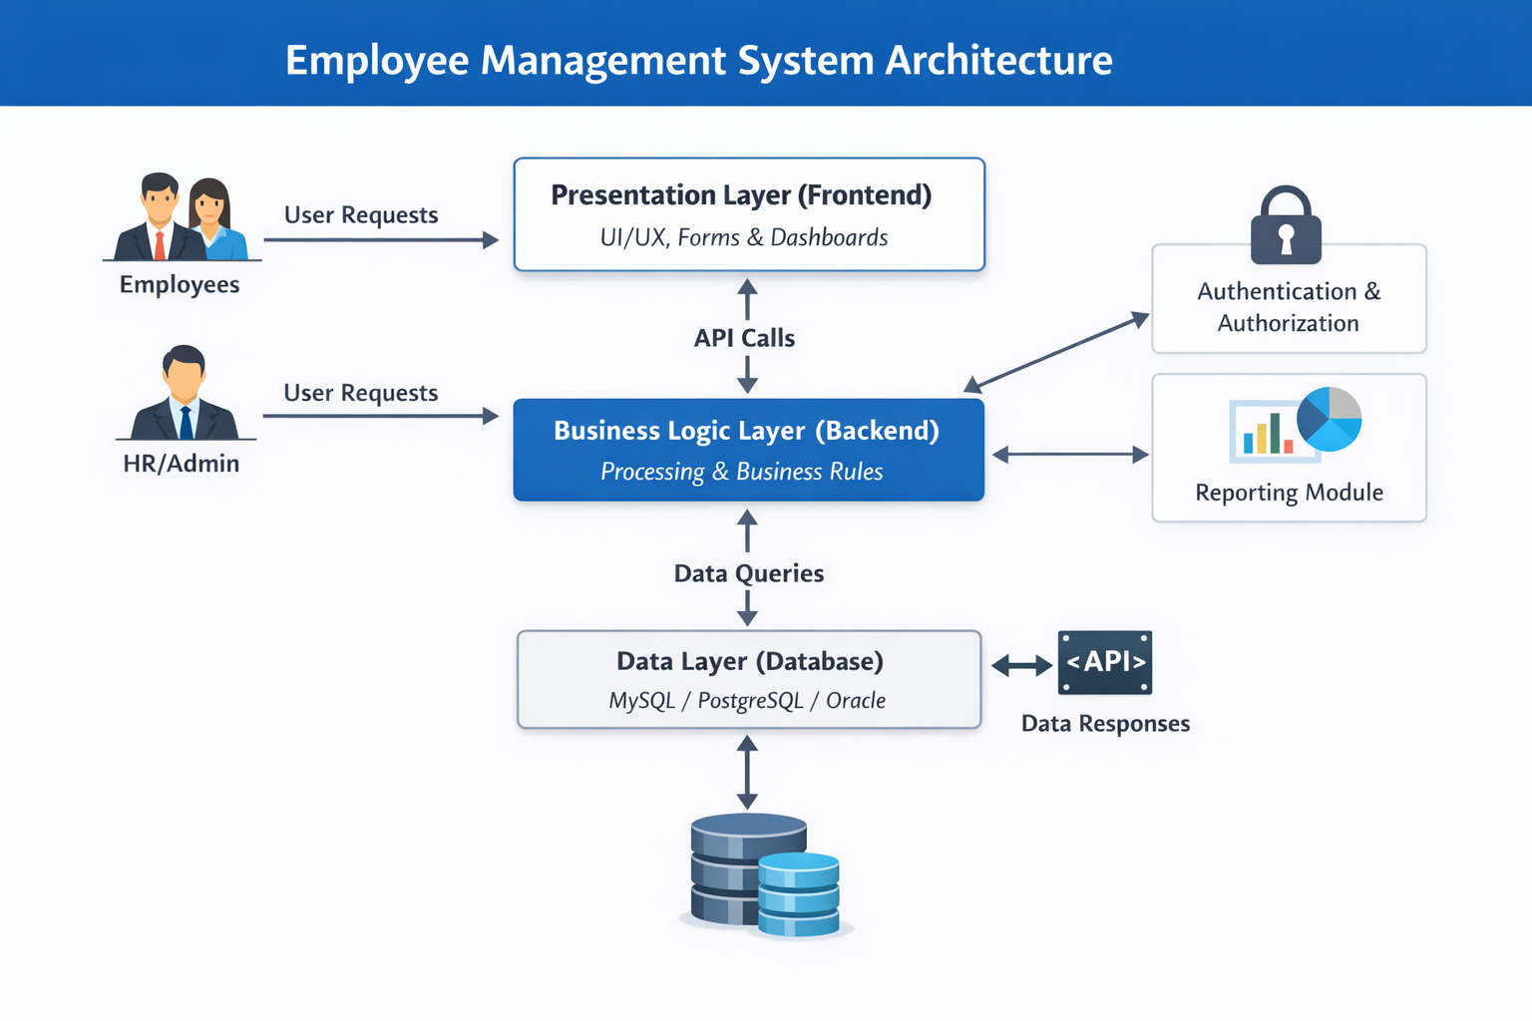

Technology Stack
The Employee Management System (EMS) is built using a combination of frontend, backend, and database technologies to ensure robustness, scalability, and a seamless user experience. The main components of the technology stack are:
- Frontend (Presentation Layer)
  - HTML5 & CSS3 – For structuring and styling web pages.
  - JavaScript – For client-side interactivity and dynamic content.
- Backend (Business Logic Layer)
  - Java (Spring Boot) – For handling server-side operations, business logic, and application workflows.
  - RESTful APIs – To enable communication between frontend and backend modules.
  - Spring Security – To implement authentication and authorization mechanisms for secure access.
- Database (Data Layer)
  - MySQL / PostgreSQL / Oracle – Relational databases for storing employee records, leave data, attendance logs, and payroll information.
- Development & Build Tools
  - Maven – For project build automation and dependency management.
  - Eclipse / IntelliJ IDEA – As IDEs for backend development.
- Version Control & Collaboration
  - Git & GitHub – For version control and collaborative development.
- Optional Tools
  - Postman – For API testing.
  - Swagger – For API documentation.
This combination of technologies ensures that the Employee Management System is efficient, secure, and scalable, providing a smooth experience for both employees and HR personnel.

+--------------------+
| Frontend |
| HTML/CSS |
+--------------------+
|
v
+--------------------+
| Backend |
| Spring Boot |
+--------------------+
|
v
+--------------------+
| Database |
| MySQL |
+--------------------+
|
v
+--------------------+
| Hosting / DevOps |
| AWS / Docker / CI |
+--------------------+

Database Design and Data Flow
Database Design is the process of structuring data in a way that ensures efficiency, integrity, and easy access. In an Employee Management System, the database acts as the backbone for storing all employee-related information.
Key Concepts:
  - Tables (Entities): Each entity represents a real-world object or concept, e.g., Employee, Department, Leave, Payroll.
  - Columns (Attributes): Describe the properties of the entity, e.g., employee_id, first_name, salary.
  - Primary Key (PK): Unique identifier for a record in a table. Ensures each record can be uniquely accessed.
  - Foreign Key (FK): Establishes relationships between tables. For example, department_id in Employee table links to Department table.
Relationships:
- One-to-Many: One department can have many employees.
- One-to-One: One employee has one payroll record per month.
- Many-to-Many: Could be used for projects assigned to multiple employees (not in current basic design).
- Importance of Database Design:
- Data Integrity: Ensures accurate and consistent information.
- Efficiency: Faster retrieval and updates of data.
- Scalability: Easy to add new modules like project management or performance tracking.
- Security: Sensitive information like salary is stored safely and accessed through controlled queries

Functional Module Description and Working Process
1. Authentication Module
Description
The Authentication Module is responsible for verifying user identity and controlling access to the system. It ensures that only authorized users can log in and access system features.
Working Process
- The user enters login credentials (username and password).
- The system validates the credentials against stored data.
- If valid, access is granted based on the user role (Admin or Employee).
- If invalid, an error message is displayed.

2. Employee Management Module
Description
This module manages employee records, including creation, updating, viewing, and deletion of employee information.
Working Process
- Admin enters employee details through the user interface.
- The system validates the data.
- Employee details are stored in the database.
- Admin or employee can view or update details when required.

3. Department Management Module
Description
The Department Module handles the creation and management of organizational departments.
Working Process
- Admin adds or updates department details.
- The system stores department information in the database.
- Employees are linked to departments through department IDs.

4. Leave Management Module
Description
This module handles employee leave applications and approvals.
Working Process
- Employee submits a leave request.
- The system records the request with status as Pending.
- Admin reviews the request.
- Leave status is updated as Approved or Rejected.
- Employee is notified of the decision.

5. Payroll Management Module
Description
The Payroll Module manages salary calculation and payment records.
Working Process
- System retrieves employee salary and leave details.
- Deductions are calculated if applicable.
- Net salary is generated.
- Payroll information is stored in the database.
- Employee can view salary details.

6. Reporting Module
Description
The Reporting Module generates reports for employees, leave records, and payroll data.
Working Process
- User selects the required report.
- System fetches data from the database.
- Report is generated in a readable format.
- User can view or download the report.

7. User Interface Module
Description
This module provides interaction between users and the system.
Working Process
- User performs actions using forms and dashboards.
- Requests are sent to the backend.
- Responses are displayed in a user-friendly format.

Security and Role-Based Access Control
Security is a critical aspect of the Employee Management System, as it handles sensitive employee information such as personal details, salary, and leave records. To ensure data confidentiality, integrity, and authorized access, the system implements Role-Based Access Control (RBAC).
Security Measures
The system follows standard security practices to protect data from unauthorized access and misuse. User credentials are securely stored, and all requests are validated before processing. Input validation is performed to prevent invalid or malicious data entry. Authentication mechanisms ensure that only verified users can access the system.

Role-Based Access Control (RBAC)
Role-Based Access Control is a security approach where system access is granted based on the user’s role. Each role has predefined permissions that restrict or allow access to specific system functionalities.
User Roles
1. Admin
- Full access to the system.
- Can add, update, and delete employee records.
- Can manage departments and payroll details.
- Can approve or reject leave requests.
- Can generate and view all reports.
2. Employee
- Limited access to the system.
- Can view and update personal details.
- Can apply for leave and view leave status.
- Can view payroll and salary information.
- Cannot modify other employees’ data.

Error Handling and Validation

Error Handling and Validation are essential components of the Employee Management System. They ensure system reliability, data accuracy, and a smooth user experience by preventing incorrect data entry and handling unexpected system failures gracefully.

Input Validation
Input validation ensures that only correct and meaningful data is accepted by the system before processing.

Types of Validation
- Client-side Validation:
Performed at the frontend to check mandatory fields, data formats (email, phone number), and value limits.
- Server-side Validation:
Performed at the backend to ensure data integrity even if client-side validation is bypassed.

Examples
- Mandatory fields cannot be left empty.
- Email addresses must follow a valid format.
- Salary values must be numeric and positive.
- Leave dates must be valid and logically ordered.

Output Interface

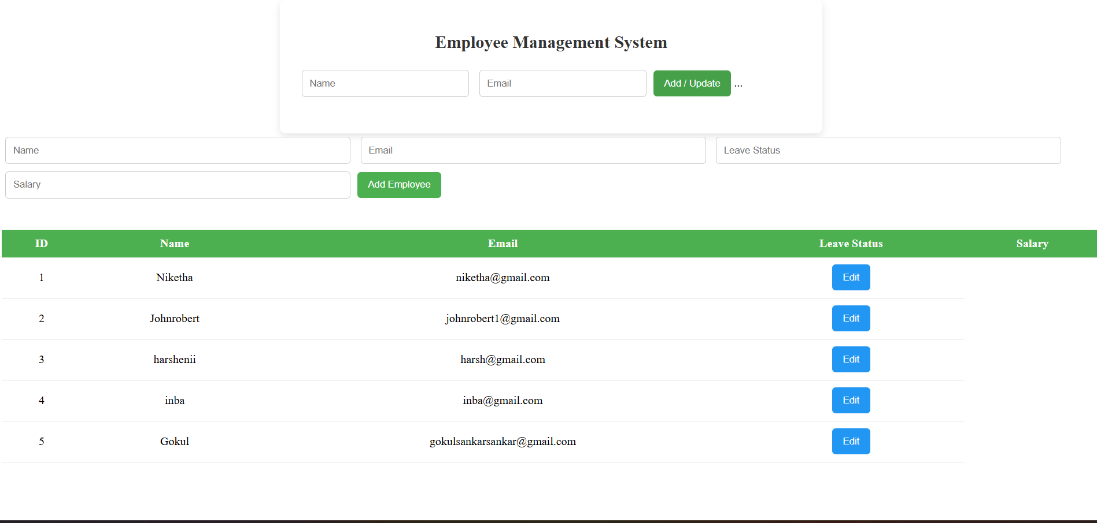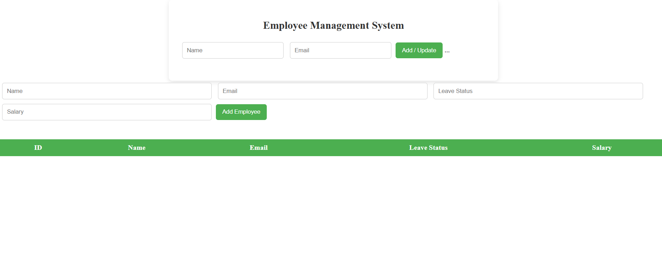
- Testing and Execution

Testing is the process of evaluating the system to identify errors, verify functionality, and ensure quality before deployment.

Types of Testing
1. Unit Testing
- Individual modules such as Employee, Leave, and Payroll are tested separately.
- Ensures each function performs as expected.
2. Integration Testing
- Verifies interaction between frontend, backend, and database.
- Ensures correct data flow between modules.
3. System Testing
- Tests the complete application as a whole.
- Ensures all features work together correctly.
4. User Acceptance Testing (UAT)
- Conducted to confirm that the system meets user requirements.
- Feedback is collected from users for final improvements.

Future Enhancements

• Improves system functionality and performance
• Enhances user experience
• Supports organizational growth
• Increases system flexibility and security

Conclusion

The Employee Management System successfully provides an efficient and organized platform for managing employee-related activities within an organization. The system automates key processes such as employee record management, leave handling, and payroll processing, thereby reducing manual effort and minimizing errors.
By adopting a modular architecture, the system ensures better maintainability, scalability, and security. Role-based access control protects sensitive data, while proper validation and error handling enhance system reliability. Thorough testing confirms that the system performs as expected under various conditions.
Overall, the Employee Management System improves operational efficiency, data accuracy, and transparency within the organization. It serves as a reliable solution for effective human resource management and can be further enhanced in the future to meet growing organizational needs.

